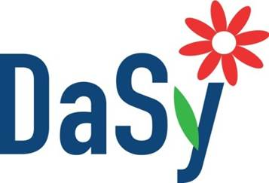

Stakeholder Engagement
Information for Detailed Stakeholder Profiles
Developing a stakeholder profile for each of the selected stakeholders will guide stakeholder engagement leaders in understanding the full range of stakeholders by role, influence, information and preferences for participation. Profiles can include, but are not limited to, the following types of information.

Information Type | Guiding Questions
Identified Role

Motivation for being in the data system work | - How will the project benefit this person in his/her work?  - How will they use the data system/data?
Perceived expectations and goals in relation to the data system work | - Do the stakeholder’s goals and expectations support or conflict with the goals of the data systems’ work?
Level of importance for the success of the data system work | - What resources might this stakeholder bring to the data systems work?  - What information or experience might this stakeholder bring to the data systems work?  - Is this stakeholder willing to take on additional roles (i.e. organizational, logistical, etc.)
Potential negative impact on the data system work | - What might this stakeholder prevent from happening?  - Are there any stakeholder interests that conflict with the data systems work?
Level of influence for decision-making | - What is the stakeholder’s power and status in relation to the data systems work?  - Does the stakeholder control key resources?  - Does the stakeholder have informal influence or personal connections that will affect the data systems work?  - What power does the stakeholder have over implementation of the data systems work, or over other stakeholders?
Intention to Participate | - Does this stakeholder want to be involved or merely need to be informed about the data systems work and its process?  - How much does this stakeholder need to participate in order to make the data systems work a success?
Preferences for Participation | - How can this stakeholder participate (as much as needed)?  - Does this stakeholder have times/days that are not convenient?  - What methodologies for involvement does the stakeholder need?

Information Type | Guiding Questions
Intention to use the results of the data systems work | - How will the stakeholder directly benefit from the data systems work?  - How could this affect their motivation to participate?

Suggestions
- This profile isn’t intended to be used as a way to eliminate stakeholders who are already involved, but rather to understand the complex ways in which stakeholders may interact with the work beyond face-to-face meetings.
- Thinking flexibly about what each stakeholder may contribute and how will create the opportunity for richer input into data systems work.

Resource – Adapted from:
Participant’s Webinar Workbook: Stakeholder Analysis Introduction. Developed by the Sustainable Management Development Program (SMDP) of the Division of Public Health Systems and Workforce Development, Center for Global Health, U.S. Centers for Disease Control and Prevention. Retrieved from: http://influenzatraining.org/documents/s18763en/s18763en.pdf, July 2014.

